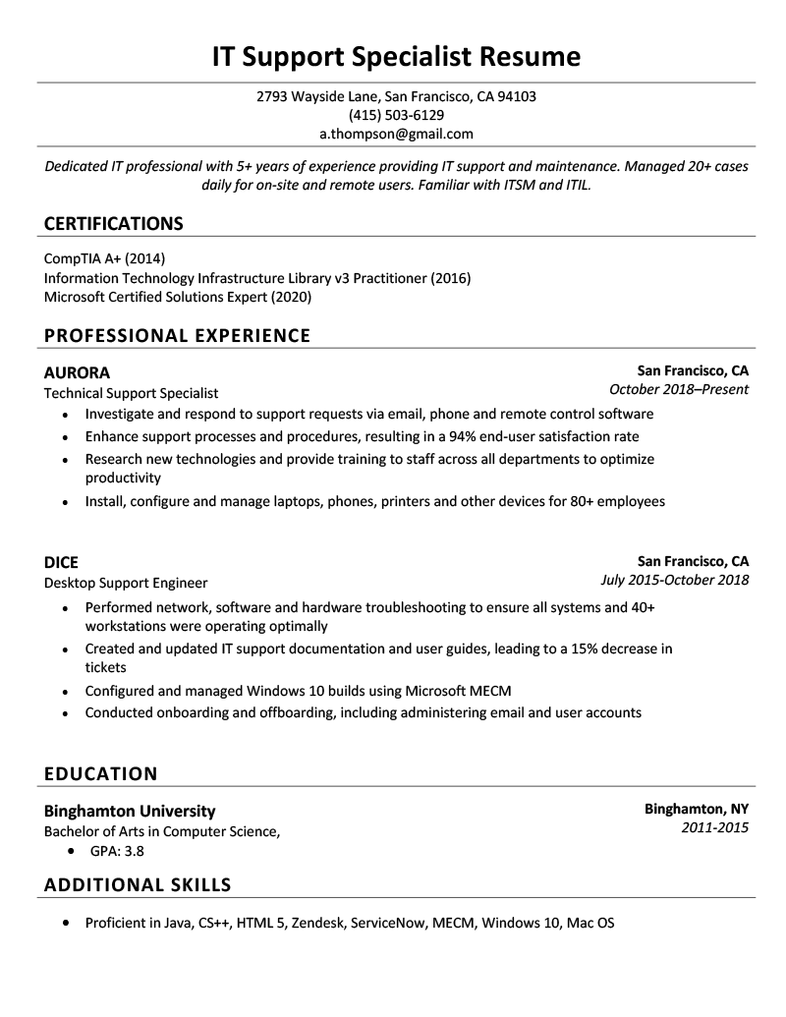
IT Support Specialist Resume
2793 Wayside Lane, San Francisco, CA 94103
(415) 503-6129 a.thompson@gmail.com
Dedicated IT professional with 5+ years of experience providing IT support and maintenance. Managed 20+ cases daily for on-site and remote users. Familiar with ITSM and ITIL.
CERTIFICATIONS
CompTIA A+ (2014)
Information Technology Infrastructure Library v3 Practitioner (2016) Microsoft Certified Solutions Expert (2020)
PROFESSIONAL EXPERIENCE
AURORA
Technical Support Specialist
San Francisco, CA
October 2018-Present
• Investigate and respond to support requests via email, phone and remote control software • Enhance support processes and procedures, resulting in a 94% end-user satisfaction rate • Research new technologies and provide training to staff across all departments to optimize productivity
• Install, configure and manage laptops, phones, printers and other devices for 80+ employees
DICE
Desktop Support Engineer
San Francisco, CA July 2015-October 2018
• Performed network, software and hardware troubleshooting to ensure all systems and 40+ workstations were operating optimally
• Created and updated IT support documentation and user guides, leading to a 15% decrease in tickets
• Configured and managed Windows 10 builds using Microsoft MECM
• Conducted onboarding and offboarding, including administering email and user accounts
EDUCATION
Binghamton University
Bachelor of Arts in Computer Science,
• GPA: 3.8
ADDITIONAL SKILLS
• Proficient in Java, CS++, HTML 5, Zendesk, ServiceNow, MECM, Windows 10, Mac OS
Binghamton, NY 2011-2015

